Institutional affiliation
Students date
Task
Date

List of figures

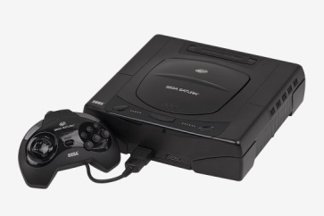
Fig 1.1 showing a console device designed by the Sega masters
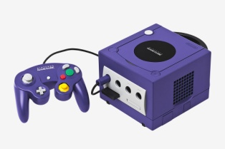
Fig 1.2 showing a console image of Nintendo GameCube
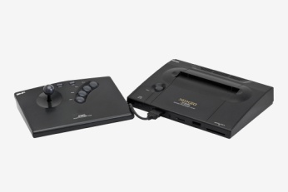
Fig 1.3 showing a console image of Neo Geo
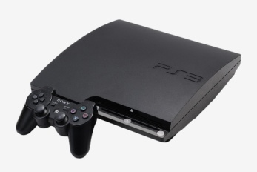
Fig 1.4 showing a console image of play station 3
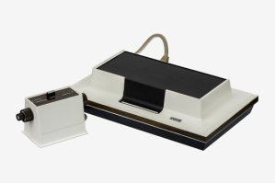
Fig 1.5 showing a console image of Magnavox odyssey

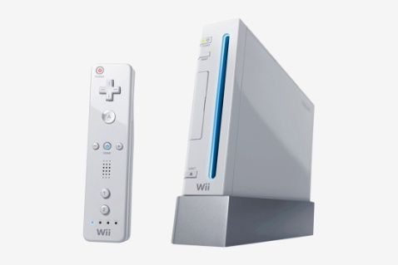
Fig 1.6 showing a console image of Nintendo Wii
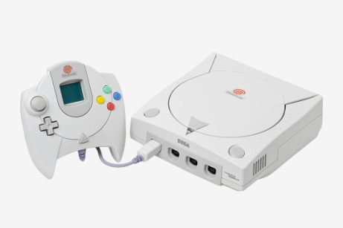
Fig 1.7 showing an image of Sega Dreamcast console
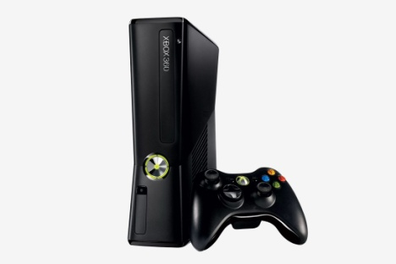
Fig 1.8 showing an image of XBOX 360 console
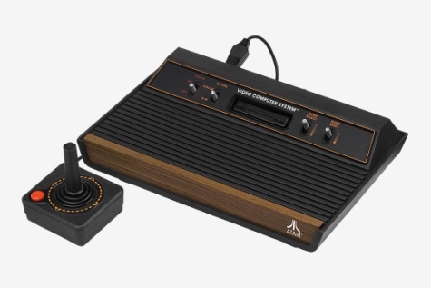
Fig 1.9 showing a console image of Atari 2600

List of tables
Second generation consoles
Name | Date | Manufacturer | Units sold
Fair Child | Nov.1976 | Fair child | 250,000
RCA | Jan.1977 | RCA | ?
Atari | Sept.1977 | Atari inc. | 30 mil.
Magnavox | Dec.1978 | Magnavox | ?
Table 1.1 showing notable consoles released by various manufacturers.
? Means the number of devices sold are not defined.
Third generation consoles
Name | Date | Manufacturer | Units sold | CPU | Bits
Videopac+ G7400 | 1983 | Philips | ? | Intel 8048 | 8
Family computer | July .1983 | Nintendo | 61 million | Ricoh 2A03 Processor | 8
Sega masters | Oct. 1985 | Sega inc. | 13 million | Zilog Z80 | 8
Family computer disc system | Feb .1986 | Nintendo | 4.4 million | Ricoh 2A03 processor | 8
Table 1.2 showing notable third generation consoles
Fourth generation consoles
Name | Date | Manufacturer | Units sold | CPU | Bits
Super FAMICOM | April 1990 | SNK | 750,000 | Motorola 68000 | 24 bits
Neo Geo | Nov 1990 | Nintendo | 49.1 million | Ricoh 5A22 | 16 bit
Sega Genesis | Oct 1988 | Sega inc | 35 million | Motorola 6800 | 16 bit

Table 1.3 showing notable fourth generation consoles
Fifth generation consoles
Name | Date | Manufacturer | Units sold | CPU | Bits
Amiga CD32 | Sept 1993 | Commodore | Above 100 million | Motorola 6800 | 32 bits
Atari Jaguar | Nov.1993 | Atari corporation | Less than 250,000 | Motorola 6800ECO20 | 64 bits
Nintendo 64 | Dec 1999 | Nintendo inc | Above 15,000 | ? | 64 bits
Name | Date | Manufacturer | Units sold | CPU | Bits
Dream cast | Nov 1998 | Sega inc | 9.1 million | HITACHI SH32 bit | 128 bits
Nintendo GameCube | Nov 2001 | Nintendo | 21 million | IBM power PC | 128 bits
Play station 2 | March 2000 | Sony | 155 million | Emotion engine | 128 bits
Table 1.5 showing sixth generation consoles
Seventh generation consoles
Name | Date | Manufacturer | Units sold | CPU
XBOX 360 | Nov 2005 | Microsoft | 83 million | 3.2 GHz PowerPC xenon
Play station 3 | Nov 2006 | Sony | 80 million | 3.2 GHz PowerPC broadband engine
Wii | Nov 2006 | Nintendo | 101 million | IBM Power PC
Table 1.6 showing notable seventh generation consoles
Eighth generation consoles
Name | Date | Manufacturer | Units sold | CPU
Wii U | Nov 2012 | Nintendo | 13 million | 1.24 GHz tricore IBM
Play station 4 | Nov 2013 | Sony | 91 million | Semi custom 8 core
Nintendo switch | March 2017 | Nintendo | 34 million | Octa core (4*ARM)
Xbox One | Nov 2013 | Microsoft | 41 million | Custom 1.75 GHz AMD 8 core APU

REFERENCES

Kirriemuir, J. (2006). 2 A history ofdigital games. Understanding digital games, 21.

Williams, D. (2005, June). A brief social history of game play. In DiGRA Conference.

